Guidelines
For
JAPAN’s Grant Assistance for
Grassroots Projects (GGP) in Bhutan

Embassy of Japan

This document was updated in June 2015
- Introduction
Since 1989, the Government of Japan has been offering a financial assistance scheme called “the Grant Assistance for Grassroots Projects (GGP)” for development projects designed to meet the diverse basic human needs of the people in developing countries. The GGP has acquired an excellent reputation worldwide for providing timely support to the local communities at the grass-roots level. In Bhutan, the GGP scheme has been supporting projects to be implemented by local governments and nongovernmental organizations (NGOs).

- Eligibility Criteria
To be eligible for the grant, the applicant must meet all the following criteria:
- The applicant must be one of the following organizations:
  - International, National or Local NGO
  - Medical Institution
  - Educational Institution
  - Community-Based Organization (CBO)
  - Local Government
- Minimum 2 years of direct/related experience in the proposed field of activity
- Not black-listed or court-listed by the state/central government. The applicant must not have any pending case with a court.
- Priority Areas of the GGP
The following are the priority areas of the GGP:
- Basic Human Needs and Human Security
- Basic Health Care
- Primary Education and Adult Illiteracy
- Poverty Alleviation
- Safe Drinking Water and Sanitation
- Women’s Empowerment
- Child Welfare including Support for Street Children and Elimination of Child Labour
- Support for Persons with Disabilities
- Preservation of Environment

- Corporate Social Responsibility (CSR) project in collaboration with Japanese or Japanese-affiliated companies
If the project does not fall under the above mentioned areas, it is advisable to contact the corresponding GGP office (Please refer the list of corresponding office) before submission of the application.
Note:
- The following areas cannot be supported by the GGP:
- A project which is not aiming at the socio-economic development of India.
- A project which does not have clear and direct benefit at grassroots level (e.g. capacity building of NGO staff or other NGO, research or higher education, commercial activities of particular organization or individual, etc.)
- A project which contains political, religious or military purpose
- A project related to the items which may harm people’s health (e.g. alcohol, tobacco, etc.)
- A project focusing on art/cross-cultural activities. (Those who are interested in carrying out projects under the aforementioned area may contact the Cultural Section in the Embassy of Japan for details about another scheme called “Grant Assistance for Cultural Grassroots Projects” which may consider supporting the mentioned area.)
- In case the GGP funded project generates profit, the profit should be utilized either to meet the recurring cost of the GGP funded project or for the benefit of the target group.
- In case of projects designed for emergency relief work, please note that the sanction of such projects will depend on the merit of the plan. This is because the procedure of GGP requires time and sanction for projects may not be immediate.

- Funding
The GGP is one-time disbursement by the end of the fiscal year when its Grant Contract is signed. The maximum amount per project is 10 million Japanese Yen (fixed) and the grant is disbursed in US Dollars. We strongly recommend that organizations should make project budget based on their actual needs within this maximum amount.

Note:
- The maximum amount of grant will be decided every year according to the exchange rate (Japanese Yen to US Dollars) fixed by the Government of Japan.
- The amount of grant sanctioned will be finalized on the basis of the exchange rate notified by the Ministry of Foreign Affairs of Japan, Tokyo, just before the project approval.
- The recipient will have to bear the bank charges/commission, which the bank(s) will deduct in respect of all bank transactions.
- The recipient will also have to bear the cost deficit that may arise due to the exchange rate (US Dollars to Bhutanese Ngultrum) at the time of obtaining the grant.

- Grants are provided mainly for creating infrastructure and installation of equipments required for the execution of the project. Grants can also be provided towards the cost of conducting training programs and seminars as a part of utilization of the requested items. The sanction of grant towards this purpose, however, solely depends on the project plan.
Note: A project proposal requesting grant only for covering the cost towards conducting awareness, seminars, training programs, will not be considered.
- The GGP covers non-recurring cost of the project. In case of part funding of non-recurring cost, the components supported by the GGP must be clearly specified.
- GGP funded items cannot be primarily utilized for renting purpose. The recipient is fully responsible and accountable for the proper utilization of the sanctioned grant.
- The grant can be provided only for procuring items which would directly benefit the target beneficiaries, and is strictly not for private use of the applicant or any individual beneficiary. (e.g. office room, home-based latrines, water pipeline to individual houses etc.)
- In addition, the following expenses can be supported by the GGP upon submission of 3 quotations and selection of the least bidder.
  - Plates/plaques to indicate that the respective items are supported by the People and the Government of Japan (refer to 6. Important Note (o))
  - Expenses for the auditing on the GGP grant utilization

- However, the following items cannot be supported under the GGP scheme:
  - Any taxes (e.g. VAT, Octroi, service tax, etc.) to be paid while procuring products/services
  - Procurement of office equipments for general/administrative use
  - Consumable products (Inexpensive, nondurable and disposable items such as medicines, raw materials, tube lights, linens etc.)
  - Animal husbandry
  - Vehicle for general/administrative use
  - Cost of purchasing/procuring land where the proposed building is to be constructed (The applicant must have ownership of the land before applying for the grant)
  - Administrative and management cost
  - Recurring cost such as staff salaries, honorarium, rent for the room, telephone/electricity costs, fuel charges, regular transportation cost, maintenance cost of facilities and equipments, etc.
  - Bank charges, insurance, registration charges
  - Computers for general or administrative use
  - Cost of preparing the blue print of the building
  - Repair of existing infrastructure
  - Capacity-building of NGO staff/other NGO
  - Items for individual use (e.g. home-based latrines, etc.)

- Procedure of GGP
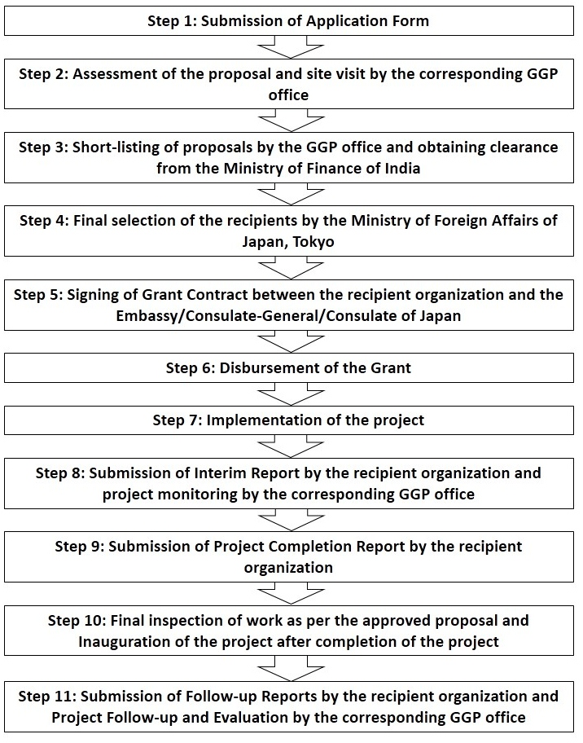

Step 1: Submission of Application Form
While preparing the project proposal, the applicant must take into account the following points:
- While screening, the GGP office give priority to the needs, relevance, impact, organizational capability, feasibility and sustainability of the project.
- The GGP will not cover recurring costs such as salaries, administrative and operation costs, travel expenses, etc. The applicant must finance these expenditures by itself or through other funds.
- The GGP sanctioned project (e.g. construction of buildings and installation of equipments) should be completed within 1 year from the date of singing the Grant Contract. Therefore, the applicant is required to form a monthly action plan.

The initial assessment will be done based on the applicant’s project proposal. An applicant who has been a recipient of the GGP grant can apply again only after the evaluation of the previous project is completed by the GGP office.

Mandatory documents to be submitted along with the application form
An applicant is required to enclose the following documents while submitting the application form. The list is not exhaustive but gives the minimum documents to be submitted. Please note that the attached documents once submitted along with the project proposal, cannot be returned to the applicant, even if so requested.

- For all projects
  - Copies of the registration certificate under the relevant registration Act
  - Brochures, pamphlets and annual reports
  - Audited financial statements for the last 3 years
  - Organizational chart with a list of staff and executive members
  - Maps and photographs indicating the location of the project site in the concerned state as well as a route map from the nearest major city to the site
  - Quotations from 3 different suppliers on proposed products and/or services duly signed by the suppliers (Each quotation must show the tax component for each item separately)
  - Copy of sanction letters from the donors, if projected in the proposal, which promise to support the specific expenses in the project.

- For building construction
  - Copy of the documents which ensure that the land for the project is possessed by the applicant organization
  - Copy of the documents which ensure that the construction is approved by the concerned local authorities
  - Copy of the documents which ensure the local authority’s approval in setting up a primary health centre, educational Institution, hospital, water plant, etc.
  - Copy of the blueprint of the building plan/design prepared and attested by the registered architect (The blueprint should show the exact total area of the building in square feet and square meter.) Any changes on the building plan should be avoided.

- For formal schools
  - Copy of the documents which ensure the permission to run schools from concerned local authority

- For hand pumps or water harvesting structure
  - Copy of the documents which ensure the possession of the land for the project
  - Copy of the documents which ensure the permission for the installation
  - Copy of the blueprint of the construction and/or installation plan/design

- For medical equipment
  - The documents and/or catalogues which show the feature, details and specification of the equipment.

Note: Some additional documents/certificates could be requested by the corresponding GGP office besides those mentioned above.

Step 2: Assessment of the proposal and site visit by the corresponding GGP
office
The GGP office will assess the applicant’s project based on the criteria as set by the Ministry of Foreign Affairs of Japan. The following points will be given careful consideration in assessing the project proposal:
- Needs identification
- Is the proposed project designed based on the needs of the beneficiaries?
- Relevance
- Is the proposed project relevant to the socio-economic conditions and needs of the project area? Are the target groups and scale of the project relevant to the criteria set forth by the GGP?
- Expected impact
- What are the expected impacts of the project?
(positive/negative, direct/indirect and short-term/long-term)
- Organizational capability
- Is the applicant capable of managing the project properly in terms of operational as well as financial aspects?
- Feasibility and sustainability
- Is the proposed project feasible in terms of its cost and time frame? Are the outcomes of the project sustainable after its completion?

Based on the assessment of the application and other necessary documents submitted by the applicant, the GGP officer will visit the project site and observe the ongoing activities for further understanding of the organizational capability and feasibility of the proposed project

Step 3: Short-listing of proposals by the GGP office

Step 4: Final selection of the recipients by the Ministry of Foreign Affairs of Japan, Tokyo

Step 5: Signing of Grant Contract between the recipient organization and the Embassy of Japan

Step 6: Disbursement of the Grant
The approved grant will be disbursed as per the Grant Contract signed between the recipient organization and the Embassy of Japan. According to the request letter submitted by the organization, the amounts will be disbursed by SWIFT or cheque and this will be/have to be deposited into the account of the recipient organization.

The amount of grant mentioned in the Grant Contract is the maximum amount that can be disbursed by the Government of Japan, and the same should be utilized for the project items as mentioned in the approved proposal. Additional expenses, such as exchange loss and escalation in project costs will have to be borne by the recipient organization.

Step 7: Implementation of the project
The recipient organization must start implementing the project as planned, immediately after the date of singing of the Grant Contract. The procurement or the signing of Procurement Contract (P/C) with contractor/supplier should be completed at the earliest. The grant must be utilized exclusively for the project.

Step 8: Submission of Interim Report by the recipient organization and project monitoring by the corresponding GGP office
Submission of Interim Report is mandatory for the recipient organization as per the terms of the Grant Contract, after conducting the site visit, hearing survey to the people concerned etc. The GGP officer may also visit the site to monitor the project.

Step 9: Submission of Project Completion Report by the recipient organization
Submission of Project Completion Report is mandatory for the recipient organization as per the terms of the Grant Contract. The Project Completion Report must include the project audit report on the project activities and financial statement, bills and vouchers. In case of finding unutilized balance after the project or any bank interest generated from the deposit of the grant, the recipient organization must inform and consult with the Embassy of Japan without delay,

Step 10: Final inspection of work as per the approved proposal and Inauguration of the project after completion of the project

Step 11: Submission of Follow-up Reports by the recipient organization and Project Follow-up and Evaluation by the corresponding GGP office
The recipient organization has a responsibility to submit Follow-up Reports for the periods notified by the corresponding GGP office after the completion of the project. The GGP officer will visit the site for follow-up and evaluation of the project in terms of its effectiveness, needs, relevance, impact, organizational capability, sustainability and efficiency.

- Important Note
- Assistance to a project under GGP is a one-time grant for 1 year.
- The applicant has to check with the corresponding GGP office about the deadline for the submission of proposal.
- The grant is a public fund raised by the taxpayers of Japan. The recipient organization is liable to answer any question that may be raised by the corresponding GGP office on behalf of the taxpayers.
- The project application should be prepared after careful reference to the “Guidelines for the GGP Application” and “Instructions for Filling-up GGP Application Form”.
- The necessary preliminary arrangements such as acquisition of land, permissions from local authorities, etc. should be done prior to the submission of the application to the corresponding GGP office. The applicant organization is requested to attach the copy of these certificates to the application.
- A project proposal that is very abstract in its objectives, activities and outcomes and gives only vague and insufficient information about the proposed project is unacceptable. Clear and detailed information, and action plan are essential to provide a complete picture of the proposed project.
- For avoiding difficulties in management, monitoring and follow-up of the project, it is necessary to confine the project to a limited area.
- The needs of the beneficiaries should be the basis of designing the plan of the proposed project
- The beneficiaries under the project should be quantifiable.
- Statistical data at the local, state and national levels to show the situation of the proposed field of activity is particularly vital in order to explain the needs of the beneficiaries. Details about the socio-economic background and problems faced by the target group should be given and supported by the secondary data with a reference information.
- It is important for the applicant organization to have all the necessary expertise in the proposed field of work. In this regard, the applicant should provide details of the previous/present work related to the proposed project. Evaluation of the previous/present work by some external agencies can be attached, if available.
- Priority will be given to needs, relevance, impact, organizational capability, feasibility and sustainability of the project while assessing the project.
- The recipient is liable to maintain the supported items in good condition until its lifetime.
- The recipient is obligated to refund full amount of grant in case the grant is utilized for any purpose other than the approved one, or if the recipient suspends/terminates the execution of the project without consulting with the corresponding GGP office.
- Plates/plaques/stickers with the words “From the People of Japan” are to be affixed to indicate items (e.g. building, equipments, etc.) funded by the GGP. (The corresponding GGP office can provide the logo-mark stickers. In case of items used outside or building, engraved plates/plaques are advisable.) The logo is as below:

(Logo mark of Japan’s national flag)

- The recipient organization is encouraged to actively promote the publicity of the project supported by Japan.

- The Corresponding GGP Office
For further enquiries or clarifications, please contact the corresponding GGP office, and make prior appointment for a meeting with the office.
GGP Unit, Economic Section,
The Embassy of Japan in India
50-G, Chanakyapuri, New Delhi, 110021
Tel: 011-2687-6564
Fax:011-2611-0752

