13th Japan Media Arts Festival

“The 13th Japan Media Arts Festival” Award-winning Exhibition will be held from Wednesday February 3, 2010 to Sunday, February 14, 2010 at The National Art Center, Tokyo (Roppongi).
This hands-on exhibition shows about 180 works of art, animations, films, games, web works, manga and others selected from among 2,592 entries from 54 nations and regions. During the 11-day exhibition, symposia and presentations featuring award winners and the jury members, workshop for students will also be held.
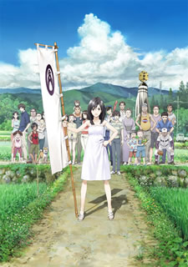
The Grand Prize in Animation Division went to "SUMMER WARS", a theatrically released work that employs both Japan’ s remote countryside and a near-future virtual world as settings for asking deep questions about the nature of human priorities.
Special Achievement Prize was awarded to MIYAMOTO Shigeru, the brains behind immortal video game classics like "Super Mario Brothers" and "The Legend of Zelda".
© 2009 SUMMERWARS FILM PARTNERS

The past grand prize works of Japan Media Arts Festival are “Princess Mononoke” by STUDIO GHIBLI, “Wii Sports” by OTA Keizou, “The House of Small Cubes” by KATO Kunio which won the Oscar (the Academy Award) of Short Film (Animated) in 2008.

－13th Japan Media Arts Festival Exhibition Information－
・Time: 10:00 – 18:00, Wednesday, February 3 – Sunday, February 14
Open until 20:00 on Fridays
The Center will be closed on Tuesday, February 9
・Venue: Special Exhibition Gallery 2E, The National Art Center, Tokyo (Roppongi)
・Admission: Free
・URL: http://plaza.bunka.go.jp/english/
・Organizer: Japan Media Arts Festival Executive Committee
(Agency for Cultural Affairs / The National Art Center, Tokyo / CG-ARTS)

* The press preview will be held at 15:00, Tuesday, February 2, and the presentation ceremony will be held at Tokyo Midtown Hall from 18:00 on the same day.

